Gap Analysis:
Delirium, Dementia and Depression in Older Adults: Assessment and Care, June 2016
Work Sheet

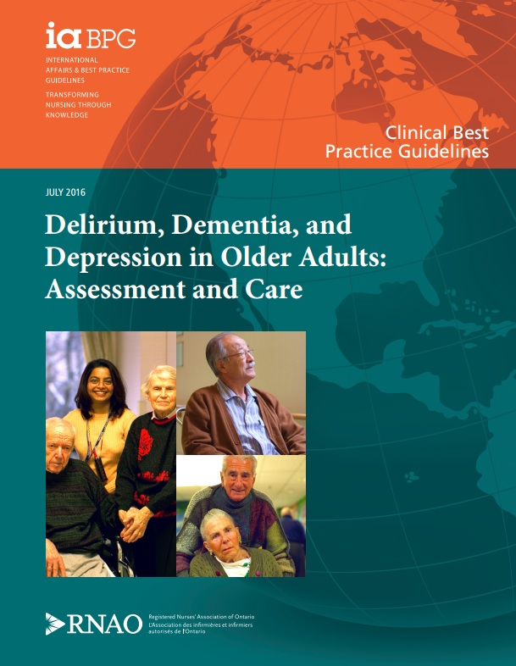

This guideline can be downloaded for free at:
http://rnao.ca/bpg/guidelines/assessment-and-care-older-adults-delirium-dementia-and-depression

The RNAO Leading Change Toolkit 3rd Edition
https://rnao.ca/leading-change-toolkit

Date Completed:
Team Members participating in the Gap Analysis:

Completion of this gap analysis allows for the annual comparison of your current practice to evidence-based practices as regulated by the MOHLTC per Fixing Long-Term Care Act, 2021 at https://www.ontario.ca/laws/statute/21f39 &
O. Reg. 246/22: GENERAL (ontario.ca)

RNAO Best Practice Guideline Recommendations | Met | Partially Met | Unmet | Notes  (Examples of what to include: is this a priority to our home, information on current practice, possible overlap with other programs or partners)
Practice Recommendations
1.0 General Recommendations Related to Delirium, Dementia, and Depression
1.1 Establish therapeutic relationships and provide culturally sensitive person- and family-centred-care when caring for and providing education to people with delirium, dementia, and depression and their families and care partners
(Level of Evidence = Ia, V)
1.2 Identify and differentiate among signs and symptoms of delirium, dementia, and/or depression during assessments, observations, and interactions with older persons, paying close attention to concerns expressed by the person, his/her family/care partners, and the Interprofessional team.
(Level of Evidence = V)
1.3 Refer older adults suspected of delirium, dementia, and/or depression to the appropriate clinicians, teams, or services for further assessment, diagnosis, and/or follow-up care.
(Level of Evidence = Ia)
1.4a Assess the person’s ability to understand and appreciate information relevant to making decisions and, if concerns arise regarding the person’s mental capacity, collaborate with other members of the health-care team as necessary.
(Level of Evidence = V)
1.4b Support the older person’s ability to make decisions in full or in part. If the older person is incapable of making certain decisions, engage the appropriate substitute decision-maker in decision-making, consent, and care planning.
(Level of Evidence = V)
1.5 Exercise caution in prescribing and administering medication to older adults (within the health-care provider's scope of practice), and diligently monitor and document medication use and effects, paying particular attention to medications with increased risk for older adults and polypharmacy.
(Level of Evidence = Ia)
1.6 Use principles of least restraint/restraint as a last resort when caring for older adults.
(Level of Evidence = Ia, V)
Recommendations Related to Delirium: Assessment
2.1 Assess older adults for delirium risk factors on initial contact and if there is a change in the person’s condition.
(Level of Evidence = Ia, V)
Recommendations Related to Delirium: Planning
3.1 Develop a tailored, non-pharmacological, multi-component delirium prevention plan for persons at risk for delirium in collaboration with the person, his/her family/care partners, and the interprofessional team.
(Level of Evidence = Ia)
Recommendations Related to Delirium: Implementation
4.1 Implement the delirium prevention plan in collaboration with the person, his/her family/care partners, and the interprofessional team.
(Level of Evidence = Ia)
4.2 Use clinical assessments and validated tools to assess older adults at risk for delirium at least daily (where appropriate) and whenever changes in the person’s cognitive function, perception, physical function, or social behaviour are observed or reported.
(Level of Evidence = Ia, V)
4.3 Continue to employ prevention strategies when caring for older adults at risk for delirium who have not been identified as having delirium.
(Level of Evidence = Ia, V)
4.4 For older adults whose assessments indicate delirium, identify the underlying causes and contributing factors using clinical assessments and collaboration with the interprofessional team.
(Level of Evidence = Ia)
4.5 Implement tailored, multi-component interventions to actively manage the person’s delirium in collaboration with the person, the person’s family/care partners, and the interprofessional team.
These interventions should include:
- treatment of the underlying causes (level of evidence = Ia),
- non-pharmacological interventions (level of evidence = V), and
- appropriate use of medications to alleviate the symptoms of delirium and/or manage pain (level of evidence = Ia).
(Level of Evidence = Ia, V)
4.6 Educate persons who are at risk for or are experiencing delirium and their families/care partners about delirium prevention and care.
(Level of Evidence = V)
Recommendations Related to Delirium: Evaluation
5.1 Monitor older adults who are experiencing delirium for changes in symptoms at least daily using clinical assessments/observations and validated tools, and document the effectiveness of interventions.
(Level of Evidence = V)
Recommendations Related to Dementia: Assessment
6.1a Assess older adults for possible dementia when changes in cognition, behaviour, mood, or function are observed or reported. Use validated, context-specific screening or assessment tools, and collaborate with the person, his/her family/care partners, and the interprofessional team for a comprehensive assessment.
(Level of Evidence = Ia, V)
6.1b Refer the person for further assessment/diagnosis if dementia is suspected.
(Level of Evidence = Ia)
6.2 Assess the physical, functional, and psychological status of older adults with dementia or suspected dementia, and determine its impact on the person and his/her family/care partners using comprehensive assessments and/or standardized tools.
(Level of Evidence = V)
6.3 Systematically explore the underlying causes of any behavioural and psychological symptoms of dementia that are present, including identifying the person’s unmet needs and potential “triggers.” Use an appropriate tool and collaborate with the person, his/her family/care partners, and the interprofessional team.
(Level of Evidence = Ia)
6.4 Assess older adults with dementia for pain using a population-specific pain assessment tool.
(Level of Evidence = Ia)
Recommendations Related to Dementia: Planning
7.1 Develop an individualized plan of care that addresses the behavioural and psychological symptoms of dementia (BPSD) and/or the person’s personal care needs. Incorporate a range of non-pharmacological approaches, selected according to:
- the person’s preferences,
- the assessment of the BPSD,
- the stage of dementia,
- the person’s needs during personal care and bathing,
- consultations with the person’s family/care partners and the interprofessional team, and
- ongoing observations of the person.
(Level of Evidence = Ia)
Recommendations Related to Dementia: Implementation
8.1 Implement the plan of care in collaboration with the person, his/her family/care partners, and the interprofessional team.
(Level of Evidence = V)
8.2 Monitor older adults with dementia for pain, and implement pain-reduction measures to help manage the behavioural and psychological symptoms of dementia.
(Level of Evidence = Ia V)
8.3 Employ communication strategies and techniques that demonstrate compassion, validate emotions, support dignity, and promote comprehension when caring for people with dementia.
(Level of Evidence = Ia)
8.4 Promote strategies for people living with dementia that will preserve their abilities and optimize their quality of life, including but not limited to:
- exercise (level of evidence = Ia),
- interventions that support cognitive function (level of evidence = Ia),
- advanced care planning (level of evidence = Ia), and
- other strategies to support living well with dementia (level of evidence = V).
(Level of Evidence = Ia, V)
8.5a Provide education and psychosocial support to family members and care partners of people with dementia that align with the person’s unique needs and the stage of dementia.
(Level of Evidence = Ia)
8.5b Refer family members and care partners who are experiencing severe stress or depression to an appropriate health-care provider.
(Level of Evidence = V)
Recommendations Related to Dementia: Evaluation
9.1 Evaluate the plan of care in collaboration with the person with dementia (as appropriate), his/her family/care partners, and the interprofessional team, and revise accordingly.
(Level of Evidence = V)
Recommendations Related to Depression: Assessment
10.1 Assess for depression during assessments and ongoing observations when risk factors or signs and symptoms of depression are present. Use validated, context-specific screening or assessment tools, and collaborate with the older adult, his/her family/care partners, and the interprofessional team.
(Level of Evidence = Ia, V)
10.2 Assess for risk of suicide when depression is suspected or present.
(Level of Evidence = V)
10.3 Refer older adults suspected of depression for an in-depth assessment by a qualified health-care professional. Seek urgent medical attention for those at risk for suicide and ensure their immediate safety.
(Level of Evidence = V)
Recommendations Related to Depression: Planning
11.1 Develop an individualized plan of care for older adults with depression using a collaborative approach. Where applicable, consider the impact of co-morbid dementia.
(Level of Evidence = Ia, V)
Recommendations Related to Depression: Implementation
12.1 Administer evidence-based pharmacological and/or non-pharmacological therapeutic interventions for depression that are tailored to the person’s clinical profile and preferences.
(Level of Evidence = Ia, V)
12.2 Educate older adults with depression (and their families/care partners, if appropriate) about depression, self-management, therapeutic interventions, safety, and follow-up care.
(Level of Evidence = V)
Recommendations Related to Depression: Evaluation
13.1 Monitor older adults who are experiencing depression for changes in symptoms and response to treatment using a collaborative approach. Document the effectiveness of interventions and changes in suicidal risk.
(Level of Evidence = V)
Education Recommendations
14.1 All entry-level health-care programs include content and practice education opportunities that are specific to caring for older adults who have or are suspected of having delirium, dementia, and/or depression, and that are tailored to the discipline’s scope of practice.
(Level of Evidence = V)
14.2 Organizations provide opportunities for nurses and other health-care providers to enhance their competency in caring for older adults with delirium, dementia, and depression. Pertinent educational content should be provided during the orientation of new staff and students, and continuously through refresher courses and professional development opportunities.
(Level of Evidence = Ia, V)
14.3 Design dynamic, evidence-based educational programs on delirium, dementia, and depression that support the transfer of knowledge and skills to the practice setting. Such programs should be:

interactive and multimodal (level of evidence = Ia),

interprofessional (level of evidence = Ia),

tailored to address learners’ needs (level of evidence = V),

reinforced at the point of care by strategies and tools (level of evidence = Ia), and

supported by trained champions or clinical experts (level of evidence = Ia).
(Level of Evidence = Ia, V)
14.4 Evaluate educational programs on delirium, dementia, and depression to determine whether they meet desired outcomes, such as practice changes and improved health outcomes. Refine programs as required.
(Level of Evidence = V)
Organization and Policy Recommendations
15.1 Organizations demonstrate leadership and maintain a commitment to foundational principles that support care for older adults with delirium, dementia, and depression, including:
- person- and family-centred care (level of evidence = 1a),
- collaborative, interprofessional care (level of evidence = 1a), and
- healthy work environments (level of evidence = V).
(Level of Evidence = Ia, V)
15.2 Organizations select validated screening and assessment tools for delirium, dementia, and depression that are appropriate to the population and health-care setting, and provide training and infrastructure to support their application.
(Level of Evidence = V)
15.3 Organizations implement comprehensive, multi-component programs, delivered by collaborative teams within organizations, to address delirium, dementia, and depression (level of evidence = Ia).
These should be supported by:
- comprehensive educational programs (level of evidence = V),
- clinical experts and champions (level of evidence = Ia), and
- organizational processes that align with best practices (level of evidence = V).
(Level of Evidence = Ia, V)
15.4 Establish processes within organizations to ensure that relevant information and care planning for older adults with delirium, dementia, and depression is communicated and coordinated over the course of treatment and during care transitions.
(Level of Evidence = Ia, V)

