Gap Analysis:
Oral Health: Supporting Adults Who Require Assistance
Second Edition
Work Sheet (Updated July 2022)

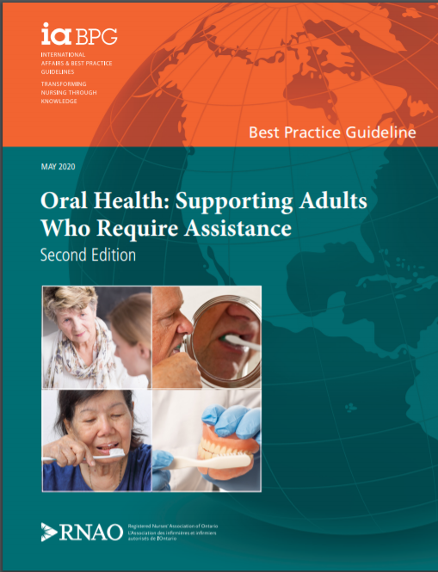

This guideline can be downloaded for free at:
https://rnao.ca/bpg/guidelines/oral-health-supporting-adults-who-require-assistance-second-edition

The RNAO Leading Change Toolkit 3rd Edition
https://rnao.ca/leading-change-toolkit

Long Term Care Toolkit: Oral Health Supporting Adults Who Require Assistance
Oral Care | Long-Term Care Best Practices Toolkit, 2nd edition (rnao.ca)

Interpretation of Evidence and Recommendation Statements
RNAO BPGs are developed using the Grading of Recommendations Assessment, Development and Evaluation (GRADE)G and Confidence in the Evidence from Reviews of Qualitative Research (CERQual)
What does certainty of evidence mean?
The certainty of evidence (i.e., the level of confidence we have that an estimate of effect is true) for quantitative research is determined using GRADE methods. GRADE categorizes the overall certainty of evidence as high, moderate, low or very low (
HIGH | We are very confident that the true effect lies close to that of the estimate of the effect.
MODERATE | We are moderately confident in the effect estimate: the true effect is likely to be close to the estimate of the effect, but there is a possibility that it is substantially different.
LOW | Our confidence in the effect estimate is limited: the true effect may be substantially different from the estimate of the effect.
VERY  LOW | We have very little confidence in the effect estimate: the true effect is likely to be substantially different from it’s estimate.
What does confidence of evidence mean?
The confidence in evidence for qualitative research (i.e., the extent to which the review finding is a reasonable representation of the phenomenon of interest) is determined using GRADE-CERQual methods

HIGH | It is highly likely that the finding is a reasonable representation of the phenomenon of interest.
MODERATE | It is likely that the finding is a reasonable representation of the phenomenon of interest
LOW | It is possible that the review finding is a reasonable representation of the phenomenon of interest.
VERY  LOW | It is not clear whether the review finding is a reasonable representation of the phenomenon of interest
Good practice statement: Refers to a practice already accepted as beneficial or practical advice. The recommended practice is believed to be so beneficial, that conducting a systematic review is unreasonable. These recommendations are not based on a systematic review and do not receive a rating of the quality of evidence or strength of the recommendation.

Recommendation: A course of action(s) that directly answers a recommendation question. It is based on a systematic review of the literature and is made in consideration of its: (a) benefits and harms; (b) values and preferences; and (c) health equity. All recommendations are given a strength through panel consensus.

Adopted recommendation: This entails using an existing, trustworthy recommendation without changes to the original recommendation. The expert panel agrees with the judgments made by the original guideline developer.
Strong Recommendation: “A strong recommendation reflects the expert panel’s confidence that the desirable effects of an intervention outweigh its undesirable effects (strong recommendation for an intervention) or that the undesirable effects of an intervention outweigh its desirable effects (strong recommendation against an intervention)” (12). A strong recommendation implies that the majority of persons will be best served by the recommended action (12).

Conditional Recommendation A conditional recommendation reflects the expert panel’s confidence that while some uncertainty exists, the desirable effects probably outweigh the undesirable effects (i.e., conditional recommendation for an intervention) or that the undesirable effects probably outweigh the desirable effects (i.e., a conditional recommendation against an intervention) (12). A conditional recommendation implies that not all persons will be best served by the recommended action and that “there is a need for more careful consideration of personal circumstances, preferences and values” (12).

Date Completed:
Team Members participating in the Gap Analysis:

Completion of this gap analysis allows for the annual comparison of your current practice to evidence-based practices as regulated by the MOHLTC per Fixing Long-Term Care Act, 2021 at https://www.ontario.ca/laws/statute/21f39 &
O. Reg. 246/22: GENERAL (ontario.ca)

RNAO Best Practice Guideline Recommendations | Met | Partially Met | Unmet | Notes  (Examples of what to include: is this a priority to our home, information on current practice, possible overlap with other programs or partners)
Recommendations
Good Practice Statement:
The expert panel recommends that, as part of their admission assessment, health providers obtain and document a person’s:
- oral health history;
- current state of oral health; and
- oral hygiene beliefs and practices, including their self-care abilities.
Practice Recommendations
Recommendation 1.0:
The expert panel suggests that health providers follow a multi-component oral care protocol that includes:
- an oral health assessment using a standardized approach and/or validated tool
appropriate to the person and health setting;
- an individualized oral care plan;
- step-by-step instructions for oral care, including tooth and denture brushing; and
- identification of required oral care tools and supplies
Strength: Conditional
Recommendation 2.0:
The expert panel suggests that health providers educate persons and caregivers on the following topics:
- oral health and the benefits of oral care;
- oral care techniques and procedures using return demonstration;
- establishing oral care practices; and
- how to use oral care tools and/or supplies.
Strength: Conditional
Recommendation 3.0:
The expert panel suggests that health providers use person-centred approaches to provide oral care to persons who are behaviourally complex, including:
- environmental adaptations;
- verbal and/or non-verbal communication strategies; and
- selection and modification of oral care tools and supplies
Strength: Conditional
Recommendation 4.0:
The expert panel suggests that health providers document specific successful strategies and
techniques in an individualized oral care plan that can be used when providing oral care to persons who are behaviourally complex
Strength: Conditional
Education Recommendations
Recommendation 5.0:
The expert panel suggests that academic institutions implement interprofessional oral care education for students entering health professions.
Strength: Conditional
Recommendation 6.0:
The expert panel suggests that health-service organizations provide education and training on oral care to health providers facilitated by an oral health professional. Education and training includes:
- theoretical oral health knowledge, including the definition of oral health, the risk factors for oral diseases and the methods of preventing them; and
- practical oral care skills, including tooth brushing and denture cleaning techniques
Strength: Conditional
Recommendation 7.0:
The expert panel suggests that health-service organizations provide education to health
providers that includes interactive hands-on training to identify and implement strategies and techniques that can be used when providing oral care to persons who are behaviourally complex
Strength: Conditional
Organizational Recommendation
Recommendation 8.0:
The expert panel suggests that health-service organizations implement an interprofessional
approach for the provision of oral care.

