Gap Analysis:
A Palliative Approach to Care in the Last 12 Months of Life,
March 2020
Work Sheet

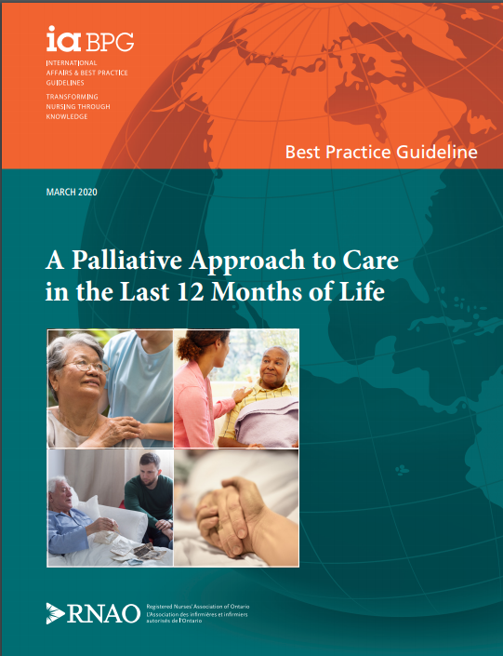

This guideline can be downloaded for free at:
https://rnao.ca/sites/rnao-ca/files/bpg/PALLATIVE_CARE_WEB.pdf

Leading Change Toolkit (3rd edition)
Leading Change Toolkit™ | RNAO.ca

Date Completed:
Team Members participating in the Gap Analysis:
Completion of this gap analysis allows for the annual comparison of your current practice to evidence-based practices as regulated by the MOHLTC per Fixing Long-Term Care Act, 2021 at https://www.ontario.ca/laws/statute/21f39 & O. Reg. 246/22: GENERAL (ontario.ca)
RNAO Best Practice Guideline Recommendations | Met | Partially Met | Unmet | Notes  (Examples of what to include: is this a priority to our home, information on current practice, possible overlap with other programs or partners)
Recommendation Question #1:
Should an interprofessional approach be recommended for the provision of care to adults in the last 12 months of life?
Outcomes: Person and family experience with care; effectiveness of provided care from the person and family perspective;
access to care; coordination of care; transitions in care; effectiveness of provided care from the health provider perspective
1.1: The expert panel recommends that health-service organizations implement an interprofessional model of care for the provision of palliative care and end-of-life care to persons and families.
Strong
1.2: The expert panel recommends that the interprofessional health team, in collaboration with the person and family, develop an individualized, person-centred plan of care and re-evaluate the plan of care based on the changing status, needs and preferences of the person.
Strong
Recommendation Question #2:
What nurse-led interventions should be recommended for a palliative approach to the delivery of care in the last 12 months of life?
Outcomes: Support for spiritual care; support for emotional care; support for existential care; care in alignment with the
person’s wishes; culturally safe care; place of death
2.1: The expert panel recommends that nurses assess the cultural needs and values of persons and families.
Strong
2.2: The expert panel recommends that nurses perform ongoing assessments of persons and families for the following:
- values, beliefs, expectations and preferences about progressive life-limiting illness and death; and
- preferred place of death.
Strong
2.3: The expert panel suggests that as part of a holistic assessment, nurses assess the spiritual, emotional and existential needs of persons and families, including:
- concerns about end of life; and
- presence of spiritual, emotional and existential distress.
Conditional
2.4: The expert panel recommends that nurses address the person’s and family’s palliative care and end-of-life care expectations
Strong
2.5: The expert panel suggests that nurses provide opportunities for life reflection to persons and families
Conditional
2.6: The expert panel recommends that nurses facilitate access to resources, space and services needed by persons and families for cultural, spiritual and/or religious practices.
Strong
2.7: The expert panel recommends that for persons who prefer to die at home, health-service organizations implement high-quality home and community care, which includes:
- access to after-hours services;
- care coordination; and
- support provided by an interprofessional health team.
Strong
Recommendation Question #3:
Should continuing education, targeted skills training and debriefing be recommended for supporting nurses and the
interprofessional health team who provide care to persons in the last 12 months of life and their families?
Outcomes: Compassion fatigue; stress/distress; resilience
3.1: The expert panel recommends that health-service organizations provide education and skills training for nurses and the interprofessional health team related to self-care, including stress management and mitigation of compassion fatigue.
Strong
3.2: The expert panel recommends that health-service organizations provide time and resources for nurses and the interprofessional health team to engage in debriefing
Strong

