Gap Analysis:
Preventing Falls and Reducing Injury from Falls, Fourth Edition 2017
Work Sheet
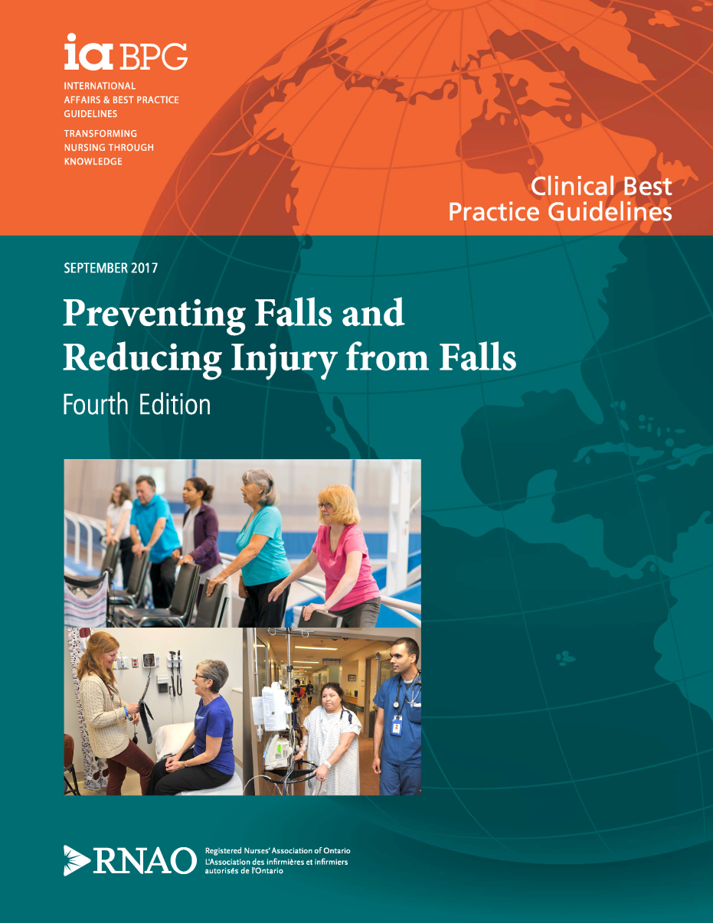

This guideline can be downloaded for free at:
http://rnao.ca/bpg/guidelines/prevention-falls-and-fall-injuries

The RNAO Toolkit: Implementation of Best Practice Guidelines, Second Edition is also available at:
http://rnao.ca/bpg/resources/toolkit-implementation-best-practice-guidelines-second-edition

LTC Best Practices Toolkit section for falls prevention is available at:
http://ltctoolkit.rnao.ca/clinical-topics/falls-prevention

Date Completed:
Team Members participating in the Gap Analysis:

Completion of this gap analysis allows for the annual comparison of your current practice to evidence-based practices as regulated by the MOHLTC. See Appendix A for this and other regulations that apply to a falls program in your home.

RNAO Best Practice Guideline Recommendations | Met | Partially Met | Unmet | Notes  (Examples of what to include: is this a priority to our home, information on current practice, possible overlap with other programs or partners)
Practice Recommendations: 1.0
1.1 Screen all adults to identify those who are at risk for falls. Conduct screening as part of admission processes, after any significant change in health status, or at least annually. Screening should include the following approaches:
- identifying a history of previous falls;
- identifying gait, balance, or mobility difficulties; and
- using clinical judgment.
(Level of Evidence = Ia & V)
1.2a For adults at risk for falls, conduct a comprehensive assessment to identify factors contributing to risk and determine appropriate interventions. Use an approach and/or validated tool appropriate for the person and health-care setting.
(Level of Evidence = III)
1.2b Refer adults with recurrent falls, multiple risk factors or complex needs to the appropriate clinician(s) or interprofessional team for further assessment and to identify appropriate interventions.
(Level of Evidence = V)
Practice Recommendations: 2.0
2.1 Engage adults at risk for falls and fall injuries using the following actions:
- explore their knowledge and perceptions of risk, and level of motivation to address risk;
- communicate sensitively about risk and use positive messaging;
- discuss options for interventions and support self-management;
- develop an individualized plan of care in collaboration with the person;
- engage family (as appropriate) and promote social support for interventions; and
- evaluate the plan of care together with the person (and family) and revise as needed.
(Level of Evidence = Ia, III, & V)
2.2 Provide education to the person at risk for falls and fall injuries and their family (as appropriate) in conjunction with other falls prevention interventions. This includes providing information about risk for falls, falls prevention, and interventions.
Ensure that the information is provided in a variety of formats and in the appropriate language.
(Level of Evidence = Ia & V)
2.3 Communicate risk for falls and related plan of care/interventions with the next responsible health-care provider and/or interprofessional team at all care transitions to ensure continuity of care and to prevent falls or fall injuries.
(Level of Evidence = V)
2.4 Implement a combination of interventions tailored to the person and health-care setting to prevent falls or fall injuries.
(Level of Evidence = Ia)
2.5 Recommend exercise interventions and physical training for adults at risk for falls to improve strength and balance. Encourage an individualized, multicomponent program/activity that corresponds to the current abilities and functioning of the person.
(Level of Evidence = Ia)
2.6 Collaborate with prescribers and the person at risk for falls to reduce, gradually withdraw, or discontinue medications that are associated with falling, when the person’s health condition or change in status allows.
This includes the following actions:
- Identify polypharmacy and medications that increase risk for falls;
- Conduct medication review, or refer to appropriate health-care provider and/or prescriber; and
- Monitor for side effects of medications known to contribute to risk for falls.
(Level of Evidence = Ia & V)
2.7 Refer adults at risk for falls or fall injuries to the appropriate health-care provider for advice about vitamin D supplementation.
(Level of Evidence = V)
2.8 Encourage dietary interventions and other strategies to optimize bone health in adults at risk for falls or fall injuries, particularly those at risk for fracture. Refer to the appropriate health-care provider for advice and individualized interventions.
(Level of Evidence = V)
2.9 Consider hip protectors as a possible intervention to reduce the risk of hip fracture among adults at risk for falls and hip fracture. Review the evidence, potential benefits, harms, and barriers to use, to support individualized decisions.
(Level of Evidence = Ia)
Practice Recommendations: 3.0
3.1 After a person falls, provide the following interventions:
- conduct a physical examination to assess for injury and determine severity of fall injury;
- provide appropriate treatment and care for injury;
- monitor for injuries that may not be immediately identified;
- conduct a post fall assessment to determine factors contributing to the fall;
- collaborate with the person and the interprofessional team to conduct further assessments and determine appropriate interventions; and
- refer to appropriate health-care provider(s), (as needed), for physical rehabilitation or to support psychological well-being.
(Level of Evidence = III & V)
Education Recommendations: 4.0
4.1 Educational institutions incorporate content on falls prevention and injury reduction into health-care education and training programs.
(Level of Evidence=V)
4.2 Health-care organizations provide ongoing organization-wide education to all staff in conjunction with other activities to prevent falls and reduce injuries.
(Level of Evidence = Ia)
Organization and Policy Recommendations: 5.0
5.1 To ensure a safe environment:
- implement universal falls precautions, and
- identify and modify equipment and other factors in the physical/structural environment that contribute to risk for falls and fall injuries.
(Level of Evidence = Ia)
5.2 Organizational leaders, in collaboration with teams apply implementation science strategies to enable successful implementation and sustainability of falls prevention/injury reduction initiatives. This includes identifying barriers and establishing formalized supports and structures within the organization.
(Level of Evidence = Ia)
5.3 Implement rounding as a strategy to proactively meet the person’s needs and prevent falls.
(Level of Evidence = Ia)

Appendix A
Applicable Ministry of Health and Long-Term Care Regulations for a Falls Prevention and Management Program

Required programs
48. (1) Every licensee of a long-term care home shall ensure that the following interdisciplinary programs are developed and implemented in the home:
1. A falls prevention and management program to reduce the incidence of falls and the risk of injury.
(2) Each program must, in addition to meeting the requirements set out in section 30,
(a) provide for screening protocols; and
(b) provide for assessment and reassessment instruments. O. Reg. 79/10, s. 48 (2).
Section 30
30. (1) Every licensee of a long-term care home shall ensure that the following is complied with in respect of each of the organized programs required under sections 8 to 16 of the Act and each of the interdisciplinary programs required under section 48 of this Regulation:
1. There must be a written description of the program that includes its goals and objectives and relevant policies, procedures and protocols and provides for methods to reduce risk and monitor outcomes, including protocols for the referral of residents to specialized resources where required.
2. Where, under the program, staff use any equipment, supplies, devices, assistive aids or positioning aids with respect to a resident, the equipment, supplies, devices or aids are appropriate for the resident based on the resident’s condition.
3. The program must be evaluated and updated at least annually in accordance with evidence-based practices and, if there are none, in accordance with prevailing practices.
4. The licensee shall keep a written record relating to each evaluation under paragraph 3 that includes the date of the evaluation, the names of the persons who participated in the evaluation, a summary of the changes made and the date that those changes were implemented. O. Reg. 79/10, s. 30 (1).
(2) The licensee shall ensure that any actions taken with respect to a resident under a program, including assessments, reassessments, interventions and the resident’s responses to interventions are documented. O. Reg. 79/10, s. 30 (2).
Falls prevention and management
49. (1) The falls prevention and management program must, at a minimum, provide for strategies to reduce or mitigate falls, including the monitoring of residents, the review of residents’ drug regimes, the implementation of restorative care approaches and the use of equipment, supplies, devices and assistive aids. O. Reg. 79/10, s. 49 (1).
(2) Every licensee of a long-term care home shall ensure that when a resident has fallen, the resident is assessed and that where the condition or circumstances of the resident require, a post-fall assessment is conducted using a clinically appropriate assessment instrument that is specifically designed for falls. O. Reg. 79/10, s. 49 (2).
(3) Every licensee of a long-term care home shall ensure that the equipment, supplies, devices and assistive aids referred to in subsection (1) are readily available at the home. O. Reg. 79/10, s. 49 (3).

